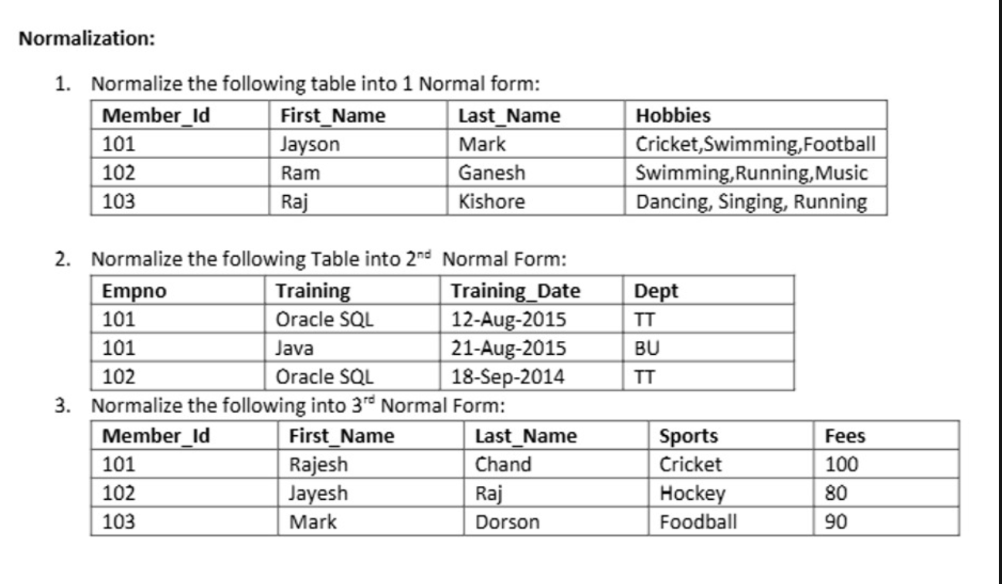
ANS 1 : - 1NF Solution:
To achieve 1NF, we split the multi-valued arrays into separate, individual rows.
Member_Id | First_Name | Last_Name | Hobbies
101 | Jayson | Mark | Cricket
101 | Jayson | Mark | Swimming
101 | Jayson | Mark | Football
102 | Ram | Ganesh | Swimming
102 | Ram | Ganesh | Running
102 | Ram | Ganesh | Music
103 | Raj | Kishore | Dancing
103 | Raj | Kishore | Singing
103 | Raj | Kishore | Running

ANS 2: - The Problem:
- Current Key: To uniquely identify a record, we need a composite primary key: (Empno, Training).
- Dependency Analysis: While Training_Date depends on both the employee and the specific training course, the Dept is determined solely by the course title (Training -> Dept, because Oracle SQL is always TT and Java is always BU).
- The Violation: This creates a partial dependency, where a non-prime attribute (Dept) depends on only a part of the primary key (Training), violating 2NF rules.
2NF Solution:
To achieve 2NF, we remove the partial dependency by breaking the data into two
separate tables:
Table 1: Employee_Training (Links employees to courses and dates)
- Primary Key: (Empno, Training)
Empno | Training | Training_Date
101 | Oracle SQL | 12-Aug-2015
101 | Java | 21-Aug-2015
102 | Oracle SQL | 18-Sep-2014

Table 2: Training_Details (Maps courses to departments)
- Primary Key: Training
Training | Dept
Oracle SQL | TT
Java | BU

ANS 3: - The Problem:
- Primary Key: Member_Id
- Dependency Analysis: Member_Id directly determines which sport a member plays (Member_Id -> Sports). In turn, the sport dictates the fee layout (Sports -> Fees).
- The Violation: This sets up a transitive dependency (Member_Id -> Sports -> Fees). 3NF rules state that no non-key attribute should dictate another non-key attribute.
3NF Solution:
To eliminate the transitive relationship, we split the sports fee matrix away from
the individual member registration profiles:
Table 1: Member_Details (Tracks member profiles and sports selected)
- Primary Key: Member_Id
Member_Id | First_Name | Last_Name | Sports
101 | Rajesh | Chand | Cricket
102 | Jayesh | Raj | Hockey
103 | Mark | Dorson | Football

Table 2: Sports_Fees (Tracks fee structures per sport)
- Primary Key: Sports
Sports | Fees
Cricket | 100
Hockey | 80
Football | 90

